# Travel

You need to add 25 things to this document. (Make sure to number them just as I did in the example.) It may be helpful to copy and paste this list and then fill it in as you go along. All image names must start with your location, e.g yellowstone_sunset.jpg unless you are using a link from the internet.

## LA

1. 
2. 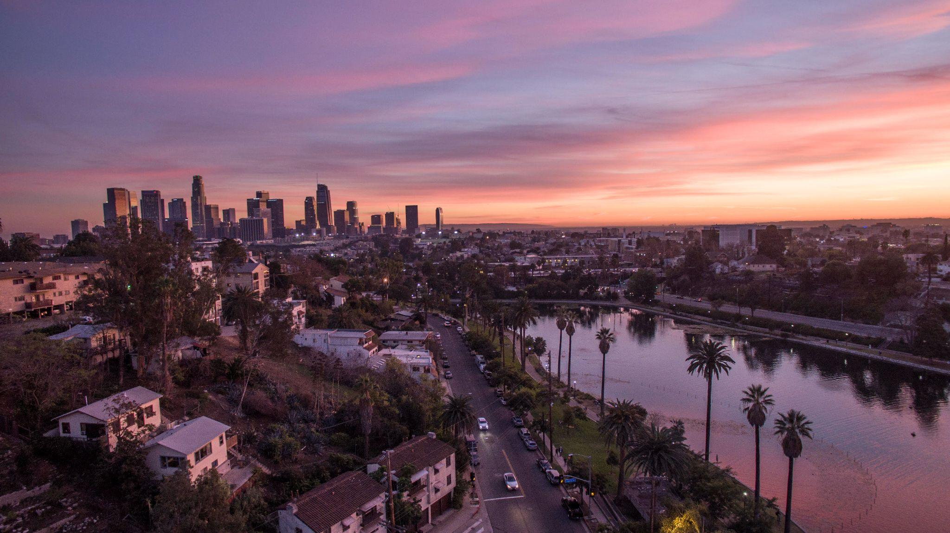
3. los-angeles-california-bustle.gif (make sure to add the picture to the proper Google Drive!)
4. los_angeles.jpeg (make sure to add the picture to the proper Google Drive!)
5. **Geographical Location**: North America
6. Paragraph One about the location:

Los Angeles is a sprawling Southern California city and the center of the nation’s film and television industry. Near its iconic Hollywood sign, studios such as Paramount Pictures, Universal and Warner Brothers offer behind-the-scenes tours. On Hollywood Boulevard, TCL Chinese Theatre displays celebrities’ hand- and footprints, the Walk of Fame honors thousands of luminaries and vendors sell maps to stars’ homes.

1. Paragraph Two about the location:

Los Angeles is famous for its idyllic, warm climate. Temperatures are high but pleasant all year round while rainfall is uncommon and mainly limited to the winter months.

For the next five pictures you can just put the names of the files, you don't have to include the files in this drive, but you do need to add them to the [proper Google Drive](https://drive.google.com/drive/folders/1sroWta5PKm63E3V2KWSUE-uYkPd_v6T5?usp=sharing).

1. **Photo Gallery – (Just write Photo Gallery)**
2. file name: downtown_la.jpeg
3. Caption of the image/movie: Downtown Los Angeles
4. skyline_la.jpg
5. Caption of the image/movie: The LA skyline set against the San Gabriel Mountains in the background.
6. file name: city_hall_la.jpeg
7. Caption of the image/movie: Los Angeles City Hall with twin towns fingerpost
8. file name: hollywood_sign.jpeg
9. Caption of the image/movie: Los angeles california hollywood sign close up
10. file name: houses_hill.jpeg
11. Caption of the image/movie: View of Houses on a Hill on Highland Ave, Los Angeles, California, USA
12. Your Name(s) Iris Sirui Wang & [Sue Yixin Wang](mailto:yixinsw@umich.edu)